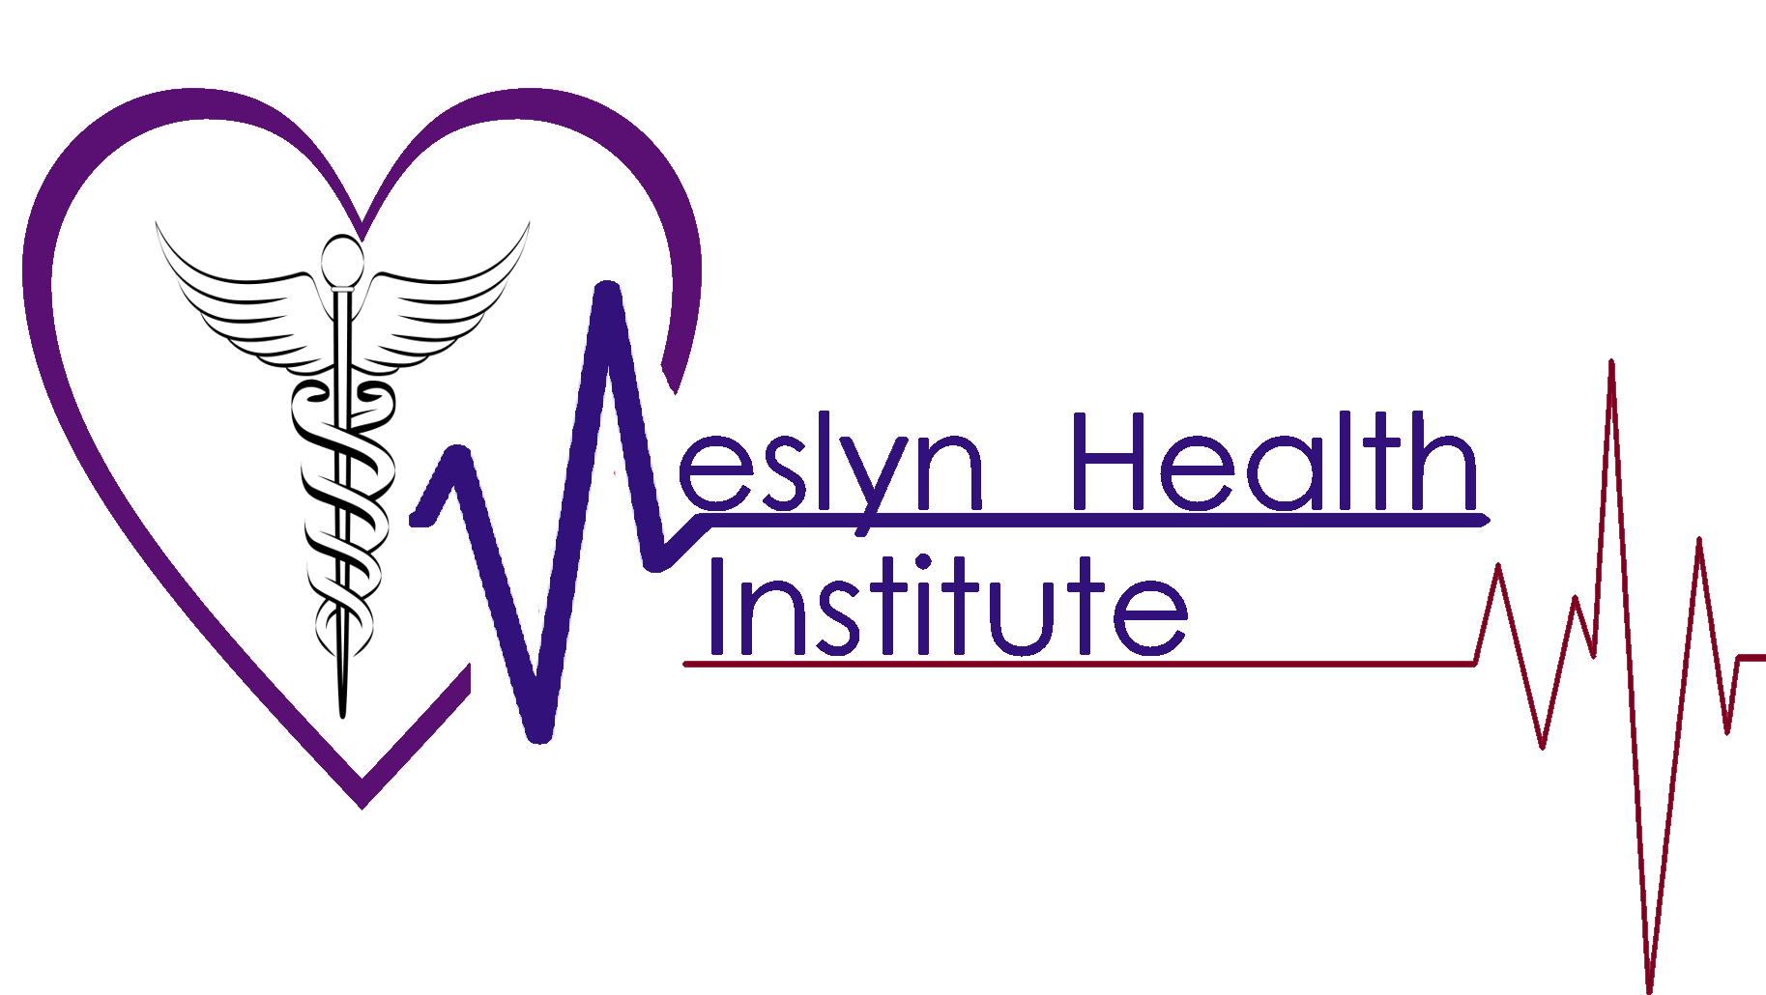

Course Schedule during Covid-19
The below courses contain an online portion to be completed along with clinical instruction. Due to Covid-19 Pandemic all classes remain closed except for limited in person labs.
Clinical sessions will be limited to 6 students. During class sessions the use of masks and gloves will be used at all times. Hand sanitizers will be used frequently and social distancing of 6 feet will be maintained as much as possible. Students temperatures will be checked prior to entering class room.

Certified Nursing Assistant 1 (5 weeks)
Instruction Type | Days/Hours | Total Hours Weekly
Online | M,T,W,Th,Fri/ 2hrs. | 10 hrs.
Lab/Clinical | M,W,Fri/ 4hrs. | 12 hrs.
Total Hours: 88 hrs.
Certified Nursing Assistant 2 (8 weeks)
Instruction Type | Days/Hours | Total Hours Weekly
Online | T,Th/ 4hrs | 8 hrs.
Lab/Clinical | M,W,Fri/ 4hrs. | 12 hrs.
Total Hours: 160 hrs.
Phlebotomy Technician (6 weeks)
Instruction Type | Days/Hours | Total Hours Weekly
Online | M,W,Fri/ 3hrs. | 9 hrs.
Lab/Clinical | T, Th (2nd week)/ 3hrs. | 6 hrs.
Total Hours: 90 hrs.

Medication Administration (3 weeks)
Instruction Type | Days/Hours | Total Hours Weekly
Online | M, Fri/ 3hrs. | 6 hrs.
Lab/Clinical | Fri/ 2hrs | 2 hrs.
Total Hours: 24 hrs.

